
OPERATIONS RESEARCH

Course No: IPE-307
Course Name: Operations Research
Project Title: Profit Maximization for Household Appliances of Walton Group Using Linear Programming

Submitted To:
Dr. Kais Bin Zaman
Professor, Department of Industrial and Production Engineering
Bangladesh University of Engineering and Technology

Submitted By:
- An-nur Taiweb Rahman
ID:1908047
- Md. Sadman Sakib Mithun
ID:1908028

Date of Submission: 03 March, 2023

Profit Maximization for Household Appliances of Walton Group Using Linear Programming

Abstract:
Local businesses like Walton Group can benefit from using linear programming to optimize their product mix for maximum profit. This project aims to determine the optimal product mix of Walton Group Household products using linear programming. An in-person survey was done in three Walton Group stores and data were collected. Then the simplex method was utilized to maximize the profit. Analysis of the survey demonstrated that Washing Machines, Television, Air conditioner, Freezer & Refrigerators were the most sold products and contributing the most to the profit. Based on the result, it is recommended to focus more on producing those items. The findings could be improved by increasing the sample size.

Introduction:
The Simplex Method is a widely used algorithm for solving linear programming problems. It was developed by George Dantzig in 1947 and has become one of the most important tools for optimization in a variety of fields including operations research, economics, engineering, and finance. In this essay, we will explore the simplex method, its steps, and its applications.
The simplex method is an iterative algorithm that begins with an initial feasible solution and improves it in each iteration. A feasible solution is a solution that satisfies all the constraints of the problem. The algorithm then moves from one feasible solution to the next by finding a feasible direction in which the objective function can be improved. This is done by selecting a variable, called the entering variable, that can be increased in value without violating any of the constraints. The algorithm then determines the value of the entering variable that will result in the maximum improvement in the objective function, called the pivot element. The entering variable replaces one of the variables in the current solution, called the exiting variable, which is set to zero.
The simplex method uses a tableau, a matrix representation of the linear programming problem, to keep track of the current feasible solution and to perform the iterations. The tableau has two parts: the objective row, which shows the coefficients of the variables in the objective function, and the constraint rows, which show the coefficients of the variables in the constraints. The variables are arranged in columns, with each column representing a variable. The last column shows the value of the constraint.

Methodology:
Quantitative data were gathered from various sources and regarded as primary data for our analysis. We have spoken with several Walton employees and surveyed three shops to gather our necessary data to asses their cost and incomes. The goal of the questionnaire was to know the prices and the quantities of the raw materials needed for producing Washing Machines, Television, Air conditioner, Freezer & Refrigerators. We have then calculated a rough estimates of their cost and income. We selected annual profit of Walton Group as our objective function. then Simplex Method was used for maximizing our objective function.
The following are the steps involved in solving a linear programming problem using the Simplex Method:
Step 1: Convert the linear programming problem into standard form
The first step is to convert the linear programming problem into standard form. Standard form requires that all variables be non-negative and that the constraints are in the form of equalities.
Step 2: Write the initial tableau
Create a matrix representation of the problem called the tableau. The tableau has two parts: the objective row and the constraint rows. Write the coefficients of the objective function in the objective row, and the coefficients of the constraints in the constraint rows. The last column of the tableau represents the constants in the constraints.
Step 3: Identify the entering variable
Choose the variable that will enter the solution in the next iteration. This variable is selected by looking for the coefficient of the objective function that is positive and has the highest absolute value.
Step 4: Find the pivot element
Find the pivot element by selecting the smallest positive ratio from the last column of the tableau (i.e., the constants in the constraints) to the corresponding coefficient in the entering variable’s column. This ratio represents the number of units of the entering variable that can be added to the solution without violating the constraints.
Step 5: Update the tableau
Divide the pivot row by the pivot element to obtain a coefficient of 1 in the pivot element. Perform row operations to make all other coefficients in the entering variable’s column equal to 0, except for the pivot element.
Step 6: Repeat the process until the optimal solution is found
Repeat Steps 3 to 5 until an optimal solution is found. An optimal solution is obtained when there are no positive coefficients in the objective row, or when all the ratios in the last column of the tableau are negative or zero.
Step 7: Interpret the solution
The final solution can be read off from the final tableau. The value of the objective function is found in the bottom-right corner of the tableau. The values of the decision variables are found in the columns where the slack variables are located. If a slack variable has a nonzero value in the final solution, it indicates that the corresponding constraint is binding.
Simplex method is tedious and time consuming to use it by hand for large number of objective variables and constraints. For that, we have utilized the powerful algorithm of Microsoft Excel.
Linear programming is helpful to structure the problem and optimize the solution, especially when there are many decision variables with a variety of resource constraints. A product mix problem for a restaurant fits into that category, so linear programming was used.

Problem Description and Formulation:
The Manufacturing Plant & Headquarters of Walton is located at Chandra, Kaliakoir, Gazipur, Bangladesh. It is approx. 5,000,000 sft. of working space consisting of 19 Buildings and Shades. Walton produces many household products in this plant. But Freezer & Refrigerator, Washing Machines, Air Conditioner, Television are their main profit earners. Annual manufacturing capacity of Freezer & Refrigerator is 2,300,000, Air Conditioner is 180,000, Washing Machines are 80,000 and Television is 800,000. The total marketing and production costs of Freezer & Refrigerator, Air Conditioner, Washing Machines and Television are BDT 20850, BDT 23538, BDT 18965 and BDT 21958 respectively. The average prices of Freezer & Refrigerator, Air Conditioner, Washing Machines and Television are BDT 37,269, BDT 49,698, BDT 33,256 and BDT 37,569 respectively. The annual manufacturing budget for all these products is around Tk 5,440 crore. The company currently has more than 30 thousand employees. Walton also has a 75% market share in refrigerators, 50% in televisions, and 20% in AC. Currently, this company is exporting its product to forty countries around the world. Walton Home Appliances currently has a total of 377 models, with a production capacity of 2.7 million units.

Item | Avg. Selling Price  (BDT) | Cost  (BDT) | Profit  (BDT) | Profit Fraction
Freezer & Refrigerator | 37,269 | 20850 | 16 419 | .2265
Air Conditioner | 49,698 | 23538 | 26160 | .36
Washing Machines | 33,256 | 18965 | 14291 | .197
Television | 37,569 | 21958 | 15611 | .2152
Total | 157,792 | 85,311 | 72,481 | 1

Item | Annual Manufacturing Capacity  (Units)
Freezer & Refrigerator | 2,300,000
Air Conditioner | 180,000
Washing Machines | 80,000
Television | 800,000

 | Raw Materials Required Per Unit Of Product
Item | Aluminum | Steel | Copper | Plastic | Glass | Rubber
Freezer & Refrigerator | 2.5 kg | 34.67 kg | 0.55 kg | 8.35 kg | 1.4 kg | 0.91 kg
Washing Machines | 1.5 kg | 35.3 kg | 1.71 kg | 3.42 kg | 0.79 kg | 0.41 kg
Air Conditioner | 4.33 kg | 30.5 kg | 1.98 kg | 7.7 kg | 1.8 kg | 0.63 kg
Television | 1.2 kg | 0.5 kg | 0.2 kg | 9.1 kg | 1.9 kg | 0.2 kg

Raw Materials | Maximum Amount That Can be Acquired Per Year (metric tons)
Aluminum | 10,000
Steel | 100,000
Copper | 35,000
Plastic | 25,000
Glass | 4,000
Rubber | 2,200

Definition of Decision Variables:
X1 = No of units of Freezer & Refrigerator to be made per year
X2 = No of units of Air Conditioner to be made per year
X3 = No of units of Washing Machines to be made per year
X4 = No of units of Television to be made per year

Optimization Criterion:
Our objective is to maximize the profit per year.
Let Z be the profit per year.
Z is to be maximized.
Objective Function, Z = 16419*X1 + 26160*X2 + 14291*X3 + 15611*X4

Formulation of Constraints:
Capacity Constraints | Budget Constraints | Non-negativity Constraints
X1 <= 2,300,000 X2 <= 180,000  X3 <= 80,000 X4 <= 800,000 | 20850*X1+  23538*X2+  18965*X3+  21958*X4  <= 54,400,000,000 | X1 >= 0  X2 >= 0  X3 >= 0  X4 >= 0

Raw Materials Constraints
2.5*X1+1.5*X2+4.33*X3+1.2X4<=10,000,000

34.67*X1+35.3*X2+30.5*X3+0.5*X4<=100,000,000

0.55*X1+1.71*X2+1.98*X3+0.2*X4<=35,000,000

8.35*X1+3.42*X2+7.7*X3+9.1*X4<=25,000,000

1.4*X1+0.79*X2+1.8*X3+1.9*X4<=4,000,000

0.91*X1+0.41*X2+0.63*X3+0.2*X4<=2,200,000

Solution:
We solved our maximization problem using Solver command of Microsoft Excel.
The optimal solution is (X1*, X2*, X3*, X4*) = (2300000, 180000, 28621, 75842)
From the above solution, it is evident that 2300000 Freezer & Refrigerators, 180000 Air Conditioners, 28621 Washing Machines, 75842 Televisions will give us maximum profit margin.
For the optimal solution, Z = 42445795541 BDT per year.
That means Walton Group can make a profit of 42445795541 BDT annually from selling Freezer & Refrigerator, Washing Machines, Air Conditioner, Television at optimal conditions.
Discussion of Results:
Here we can see optimal solution suggest us to produce Freezer & Refrigerators and Air Conditioner at max capacity. That means they are highly profitable products and brings the most profit to Walton Group. On the other hand it would not be profitable to increase production of Washing Machines and Televisions.

Here is a screen-shot of our solution:

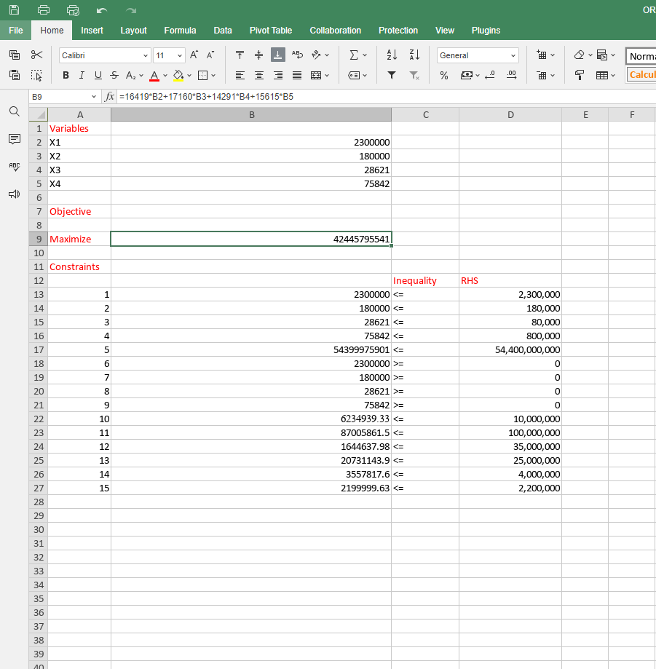

Conclusion:
In conclusion, linear programming is a powerful mathematical technique that allows us to optimize complex systems with multiple variables and constraints. It has numerous real-world applications, such as in transportation planning, production scheduling, and resource allocation. The technique involves identifying a set of linear constraints and an objective function, which is then optimized using mathematical algorithms. Linear programming can help decision-makers make more informed and efficient choices by identifying the optimal solution that satisfies all the constraints. Despite its limitations, linear programming remains a valuable tool for businesses, governments, and organizations to optimize their operations and improve their bottom line.

Reference:
- "Linear Programming Models for Production Planning and Scheduling" by V. Chandrasekaran and K. G. Kannan. International Journal of Production Economics, Vol. 23, Issues 1-3, May 1991, pp. 161-174.
- "A Multi-Objective Linear Programming Model for Production Planning and Scheduling in a Multi-Product Manufacturing System" by B. Gopalakrishnan and K. V. R. Murthy. International Journal of Production Research, Vol. 39
- "Application of Linear Programming Techniques in Production Planning and Control." by O. O. Oladejo, A. O. Abass, and F. O. Ogunwale. International Journal of Engineering Research and Applications, Vol. 3, Issue 3, May-Jun 2013, pp. 1912-1917.
- "Walton Group: The Story of Bangladesh's Biggest Conglomerate" by Rezwanul Islam. The Daily Star, November 2019. Available at: https://www.thedailystar.net/business/news/walton-group-the-story-bangladeshs-biggest-conglomerate-1826349
- "Walton Group: The Multinational Conglomerate Making Waves in Bangladesh" by Haider Rifaat. The Diplomat, October 2019. Available at: https://thediplomat.com/2019/10/walton-group-the-multinational-conglomerate-making-waves-in-bangladesh/

